Starlings Care Club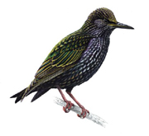Registration Form
Child(ren’s) name:

……………………………………………………………. DOB:………………..
Address:…………………………………………………………………………..
Parent(s) name:………………………………………………………………….
Doctor:……………………………………………….Tel:……………………….
Surgery Address:………………………………………………………………..
Contact numbers:………………………………………………………………..
Home:……………………………………Work:…………………………………
Mobile:…………………………………..Other:………………………………...
Name and phone numbers of other emergency contact(s):
……………………………………………………………………………………..
Any Allergies / Medical / Circumstances staff should be aware of?
……………………………………………………………………………………..
I consent to the following while my child(ren) attend Starlings Care Club
(please tick)

Using my child(ren’s) photograph in displays
Starlings staff administering medicines (complete separate medicine form)
Applying sunscreen
Using face paints
Offsite activities (within 1 mile of the school grounds)
Take part on cooking / tasting activities

